Batch: A-3 Roll No.: 16010122104
Experiment No. 5
Grade: AA / AB / BB / BC / CC / CD /DD

Title: Creating a Virtual Machine on GCP using Google Cloud Skills Boost

Objective:

Expected Outcome of Experiment:

CO | Outcome
CO4 | Build cloud services and applications

Books/ Journals/ Websites referred:

https://www.cloudskillsboost.google/

Abstract:-
Compute Engine Overview
Google Compute Engine provides virtual machines (VMs) as Infrastructure-as-a-Service (IaaS), allowing users to run applications on scalable, virtualized hardware.

Related Theory: -
Key Concepts
- Virtual Machines (VMs): Software-based computers running isolated workloads.
- Regions and Zones: Geographical locations affecting latency and redundancy.
- Machine Types: Predefined or custom configurations (general-purpose, compute-optimized, memory-optimized).
- Persistent Disks: Durable storage attached to VMs.
Methods to Create VMs
Method | Description
Google Cloud Console | Graphical interface for easy setup
gcloud CLI | Command-line tool for automation
Creating a VM via Console
- Go to Compute Engine > VM Instances.
- Click "Create instance".
- Set machine type, boot disk, firewall rules.
- Click "Create".
Creating a VM via CLI
bash
gcloud compute instances create INSTANCE_NAME --machine-type MACHINE_TYPE --zone ZONE
Connecting via SSH
bash
gcloud compute ssh INSTANCE_NAME --zone ZONE
Deploying Web Servers (e.g., NGINX)
bash
sudo apt update
sudo apt install nginx -y

Implementation Details:
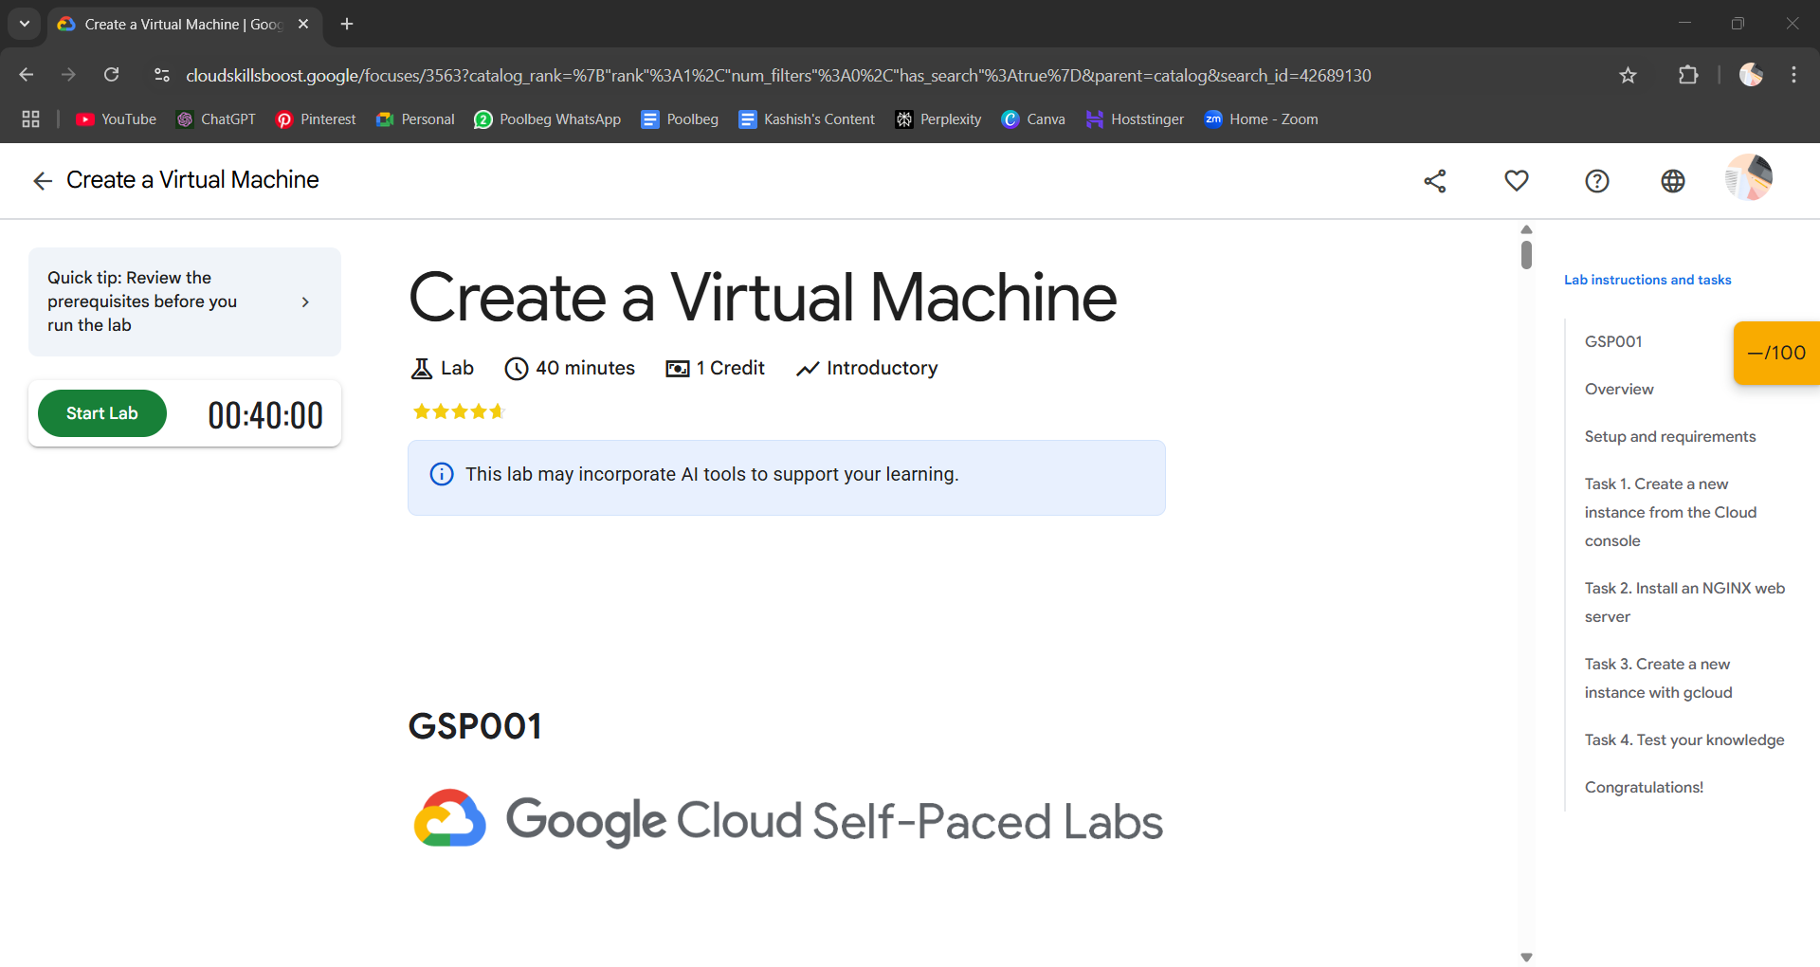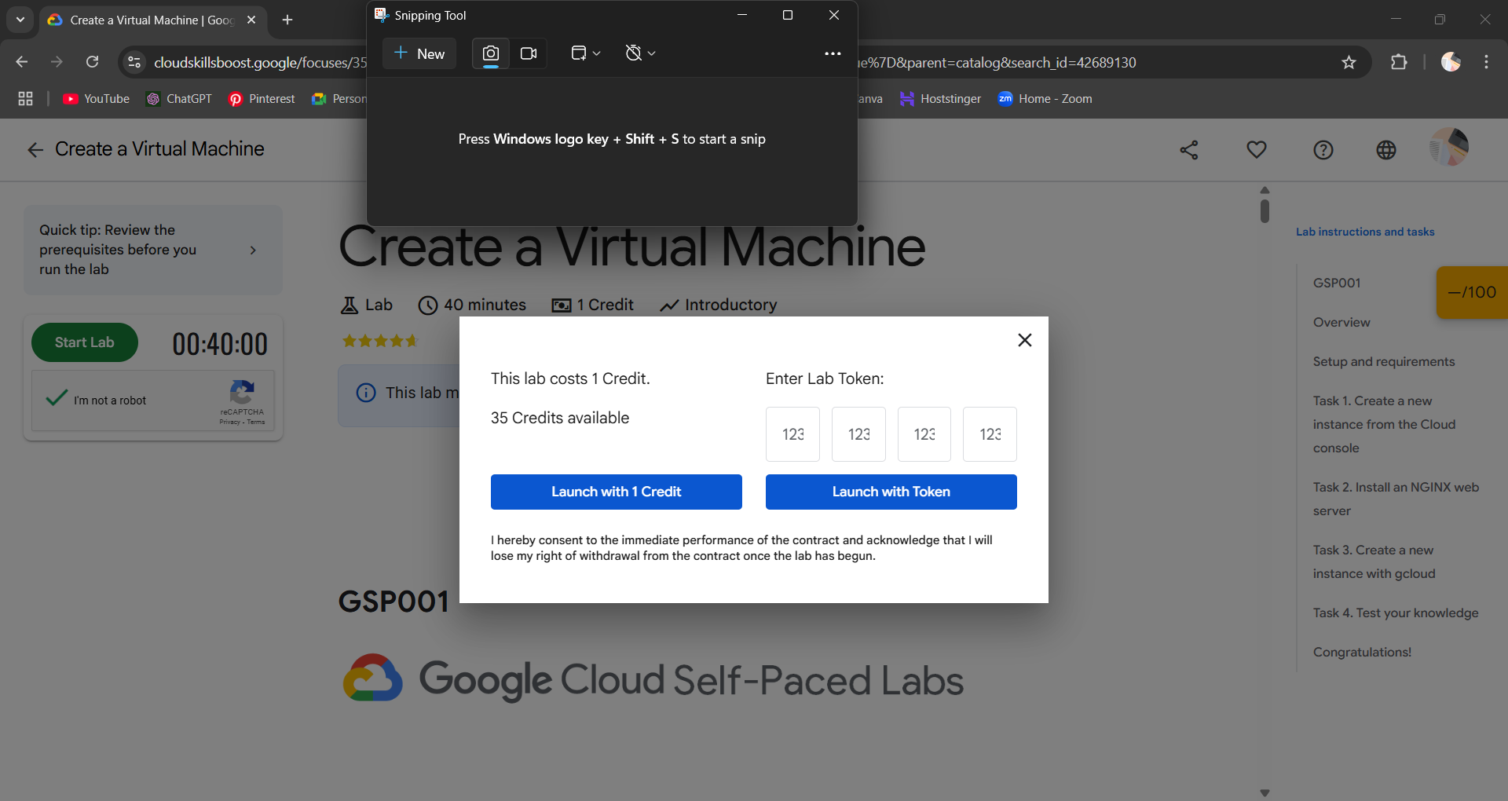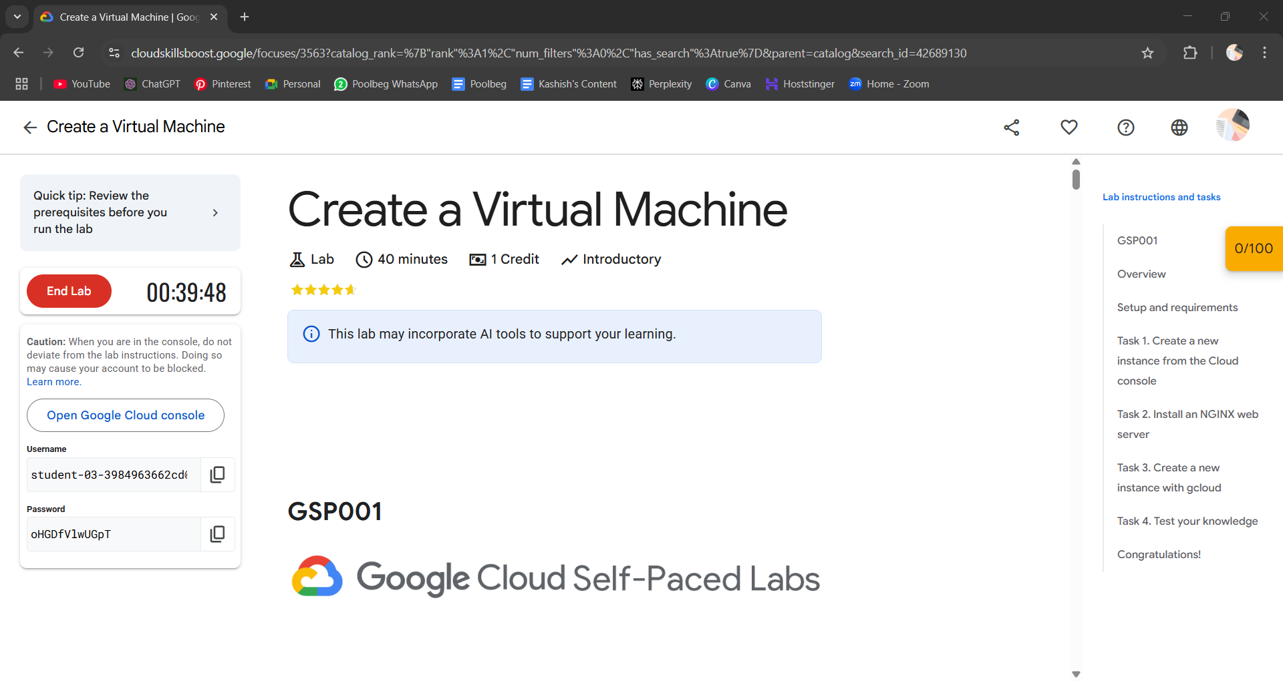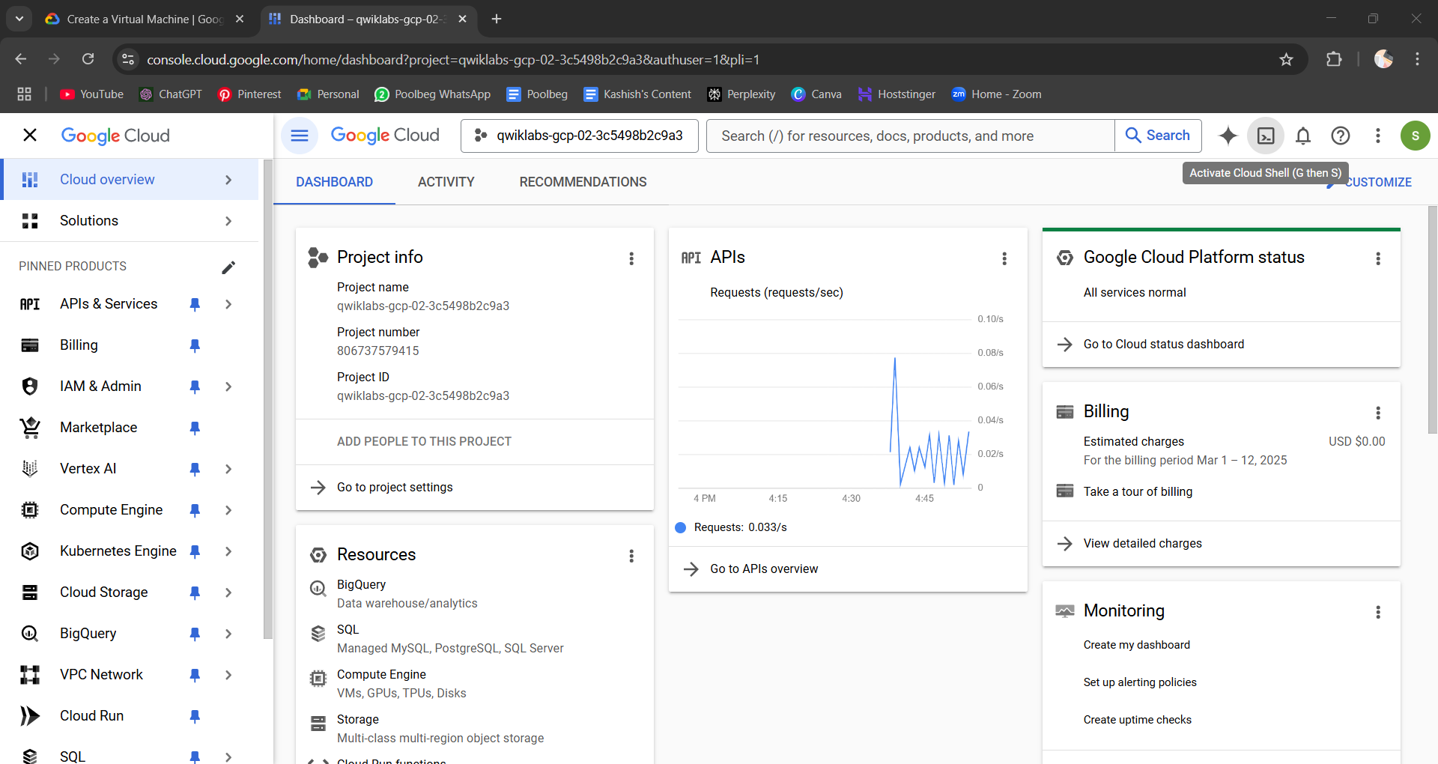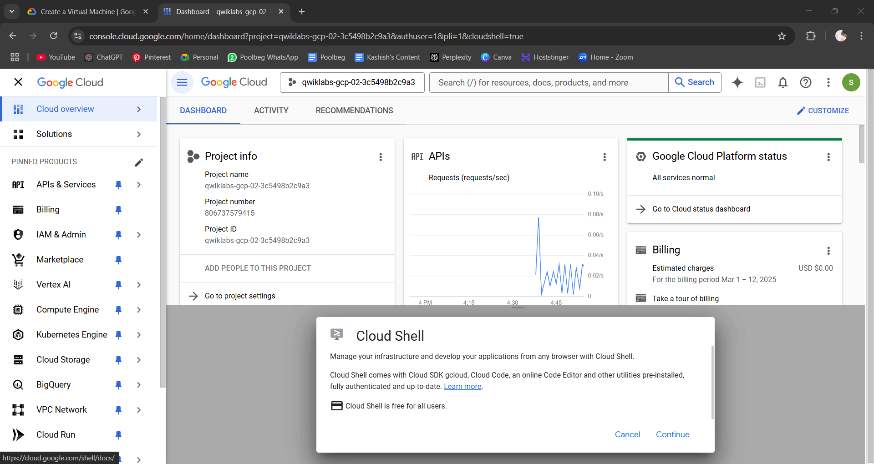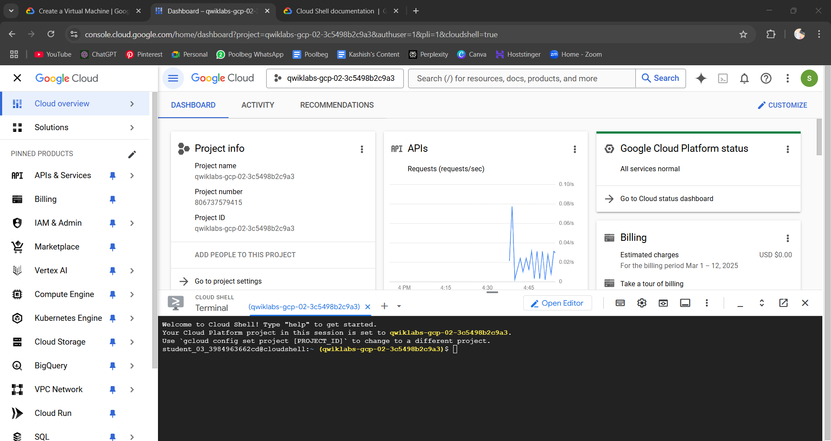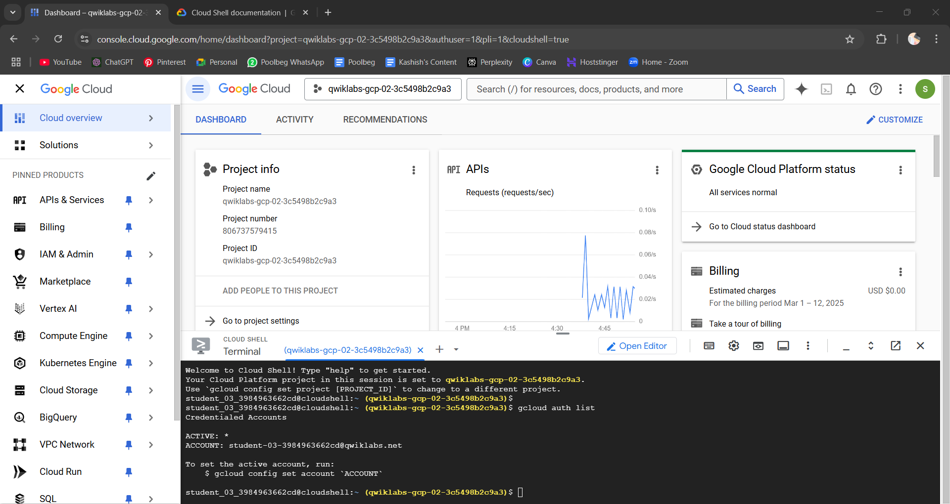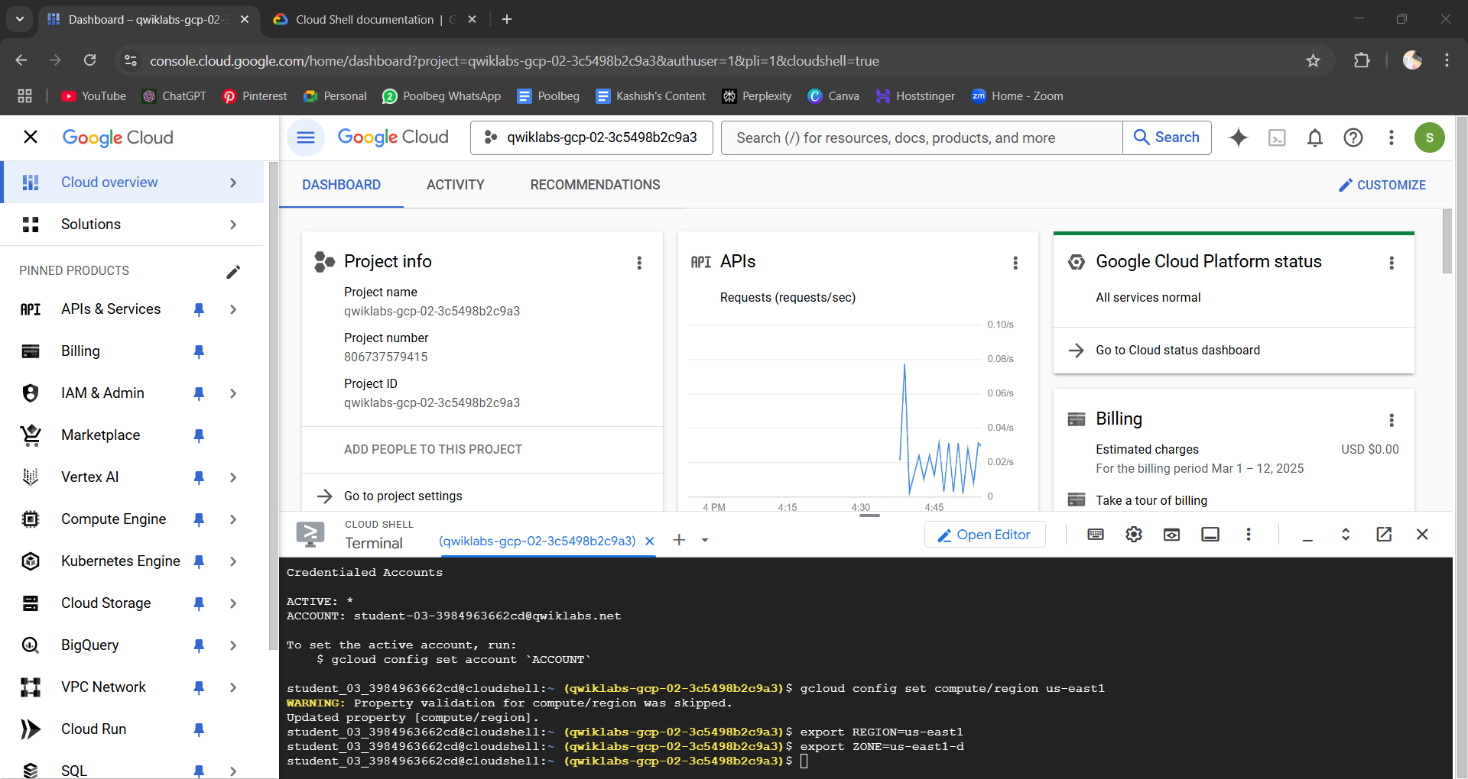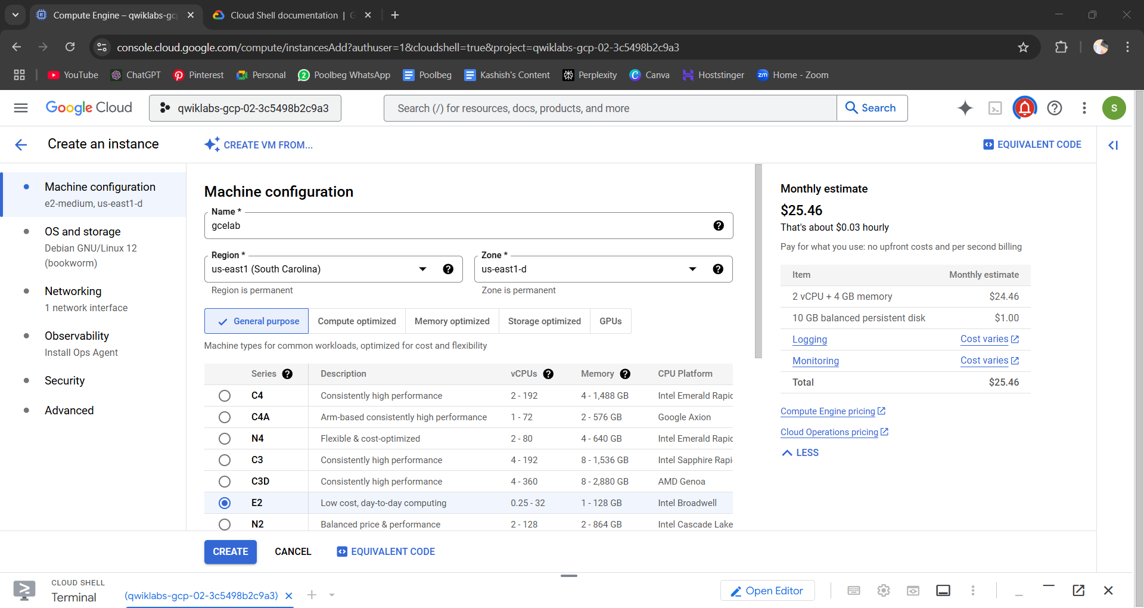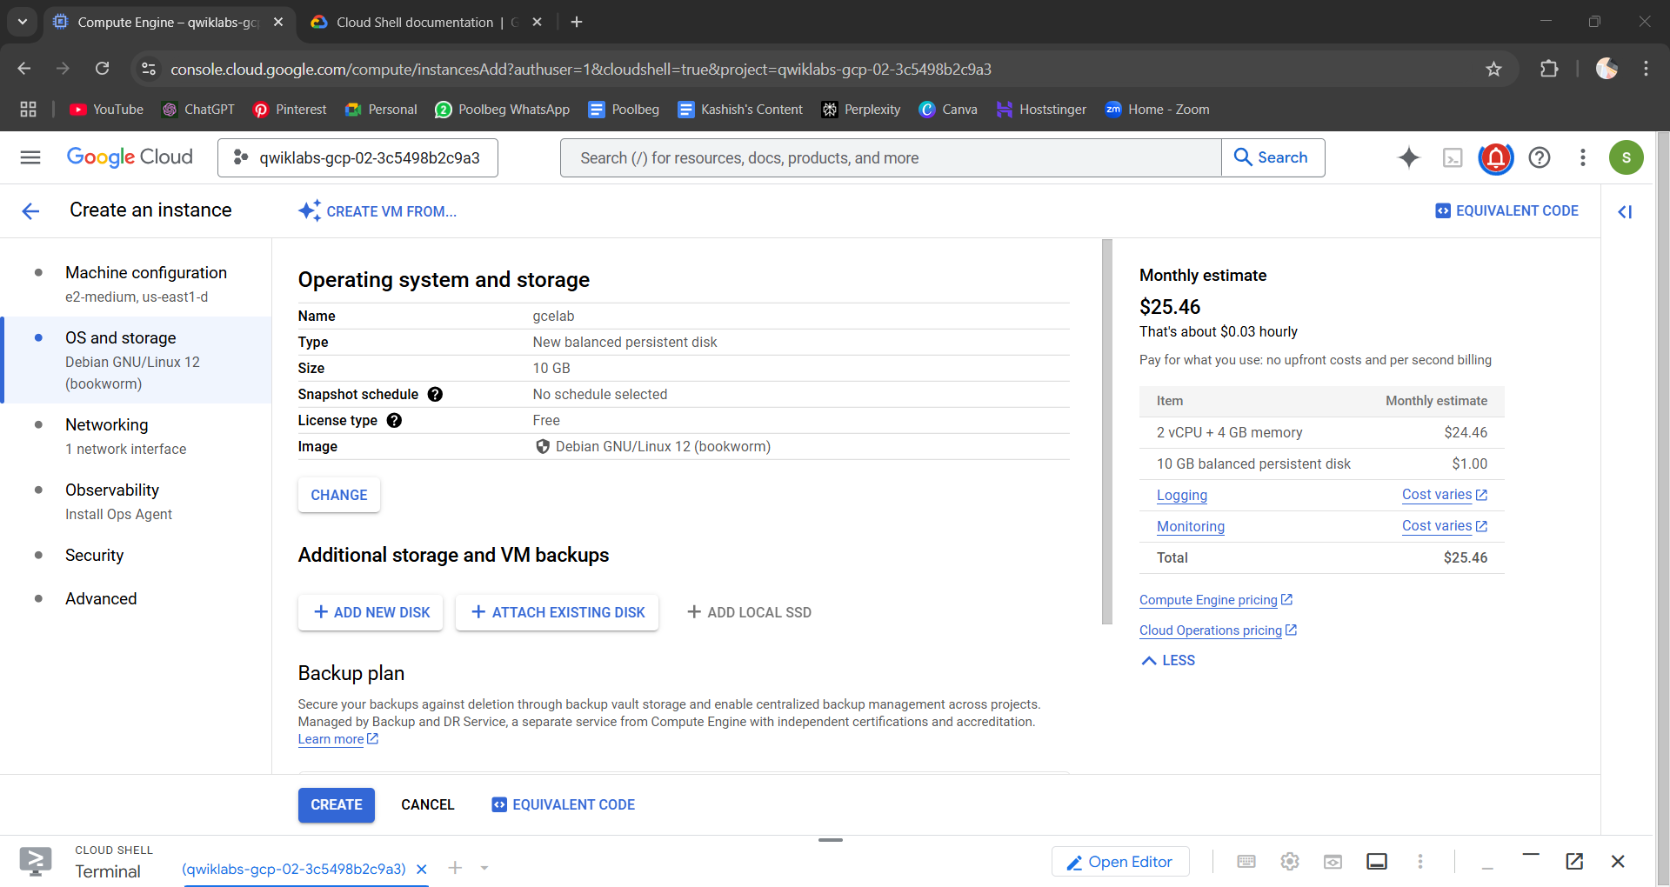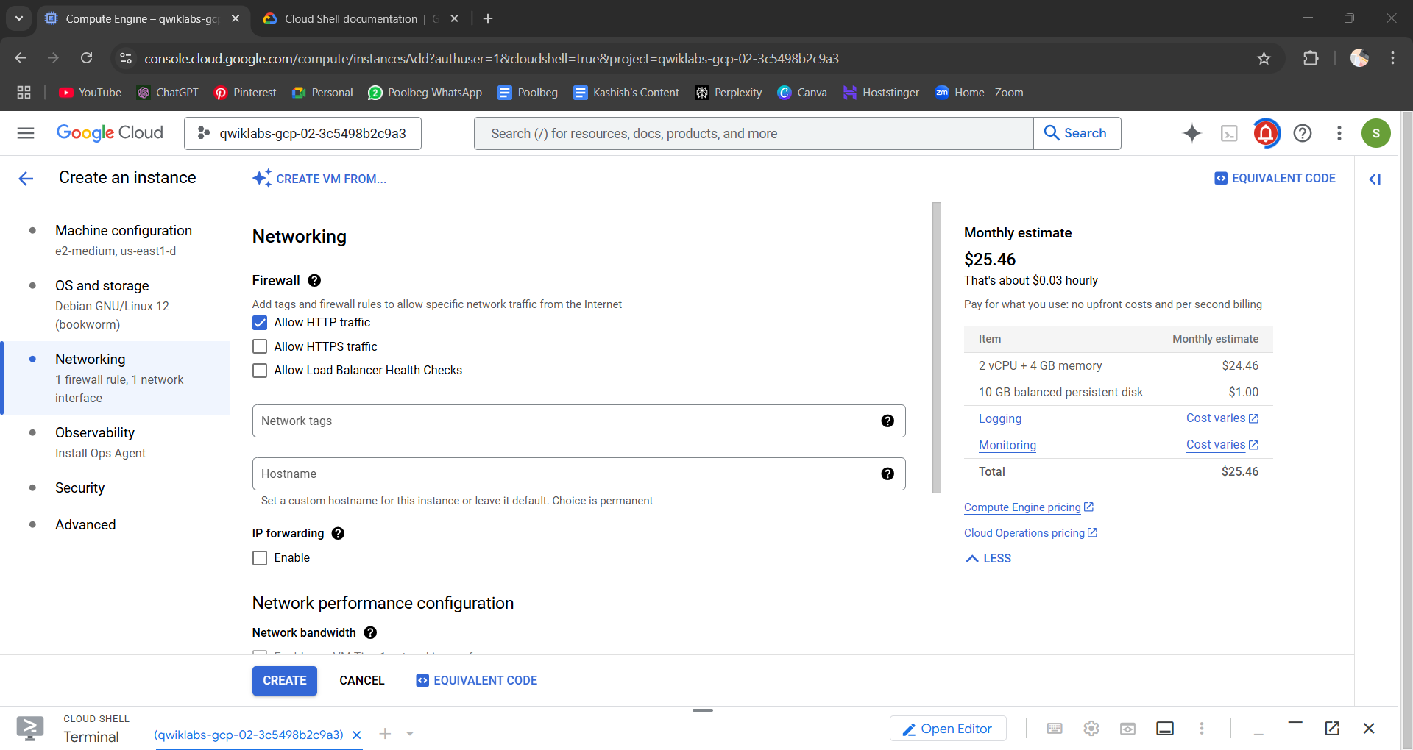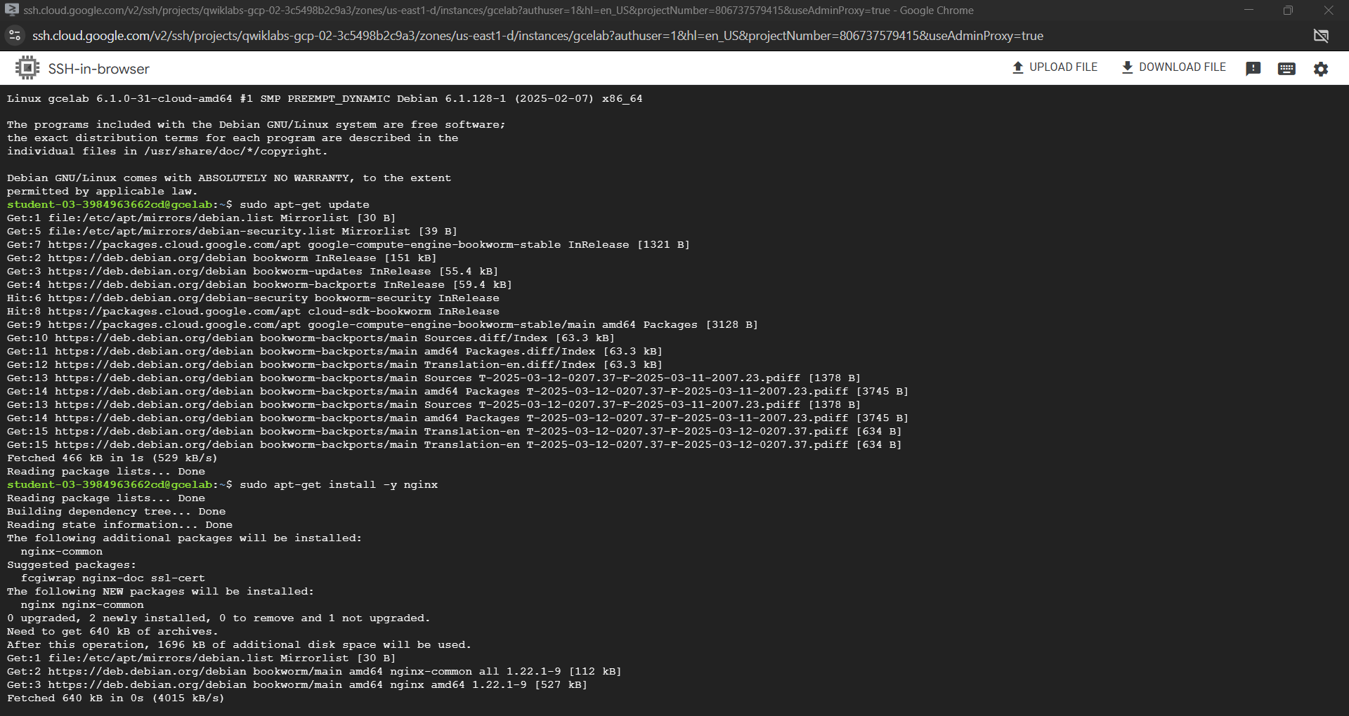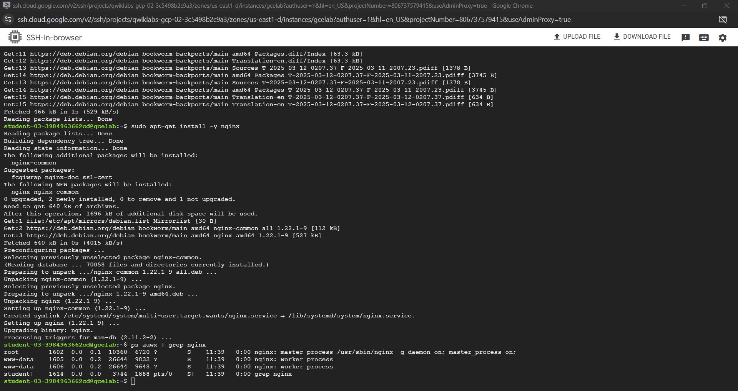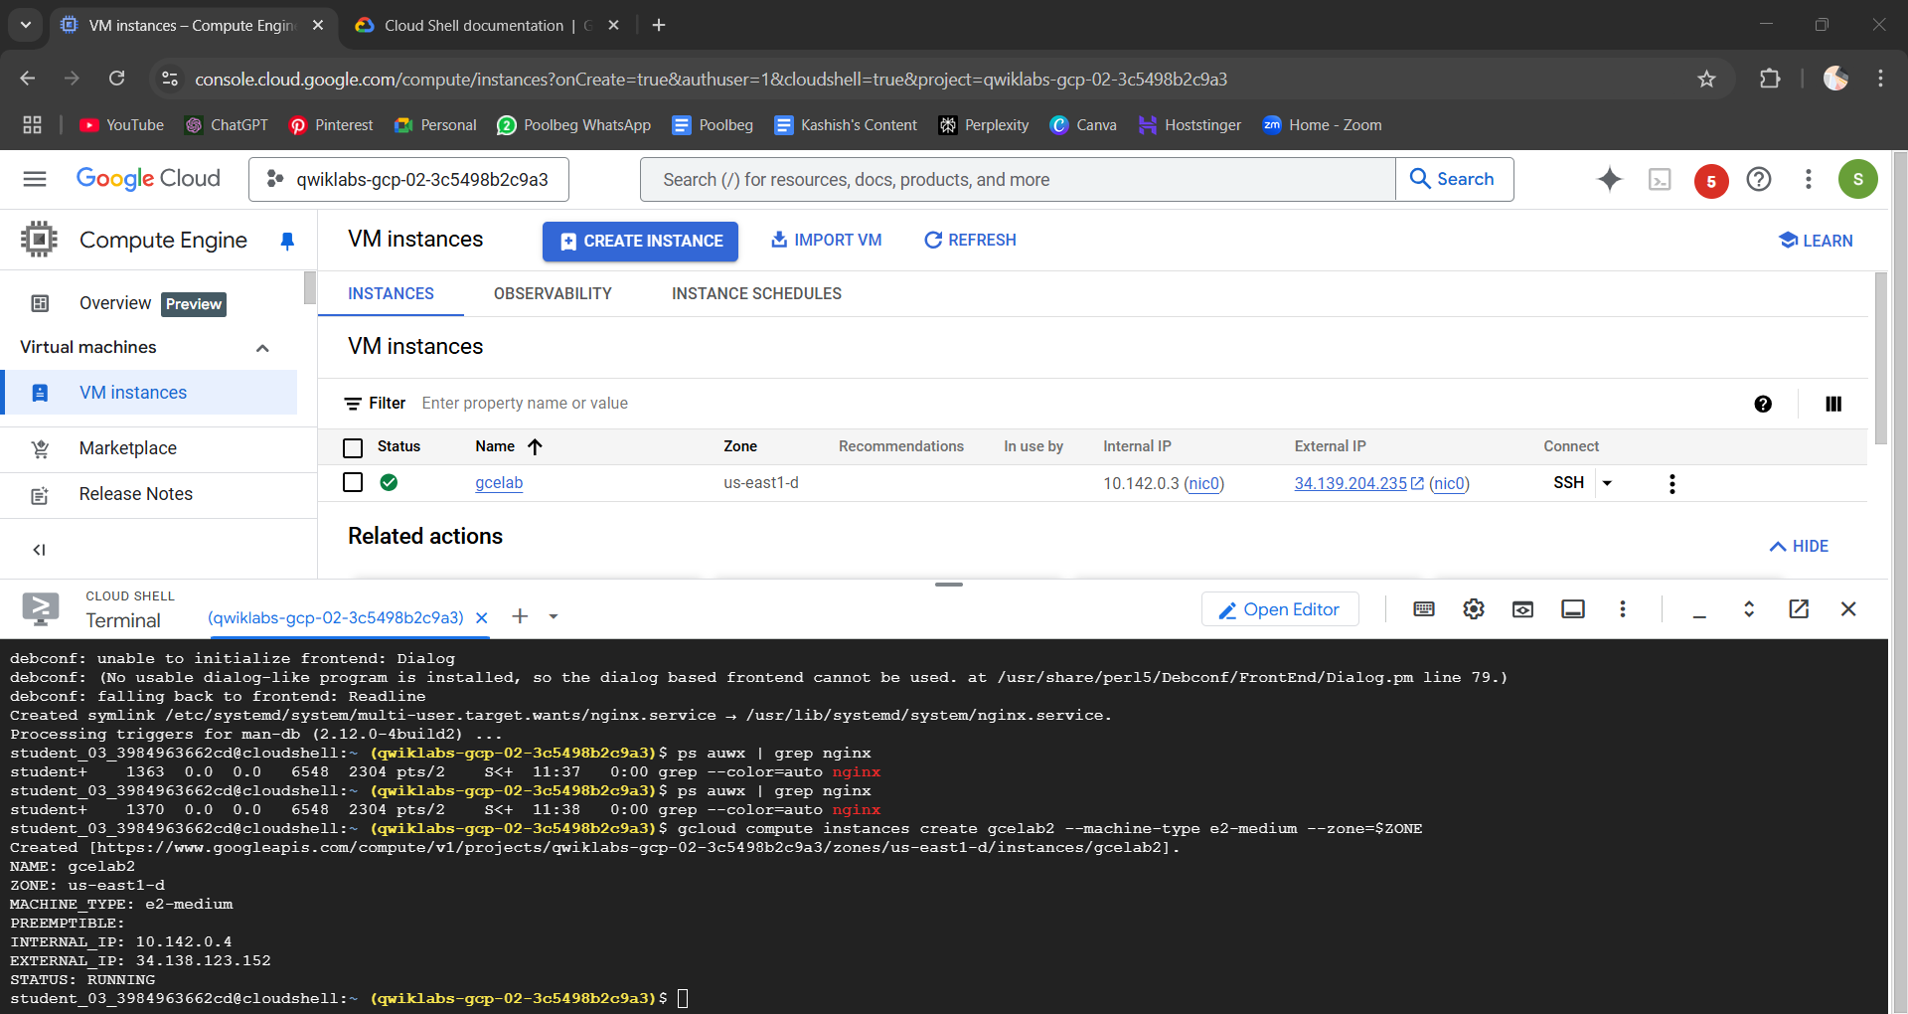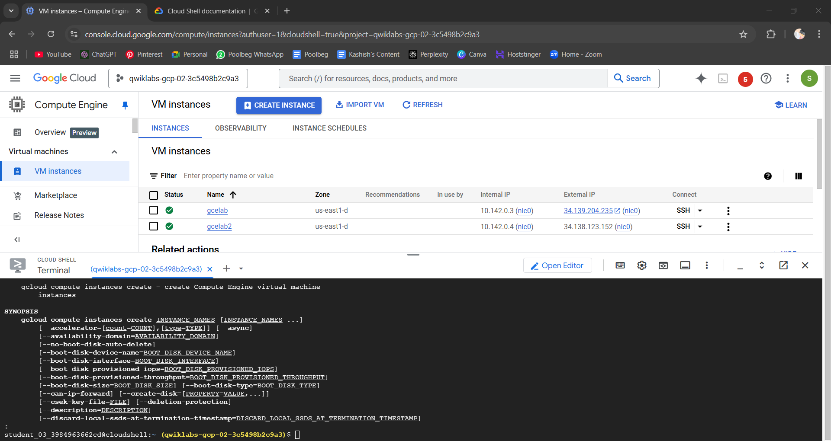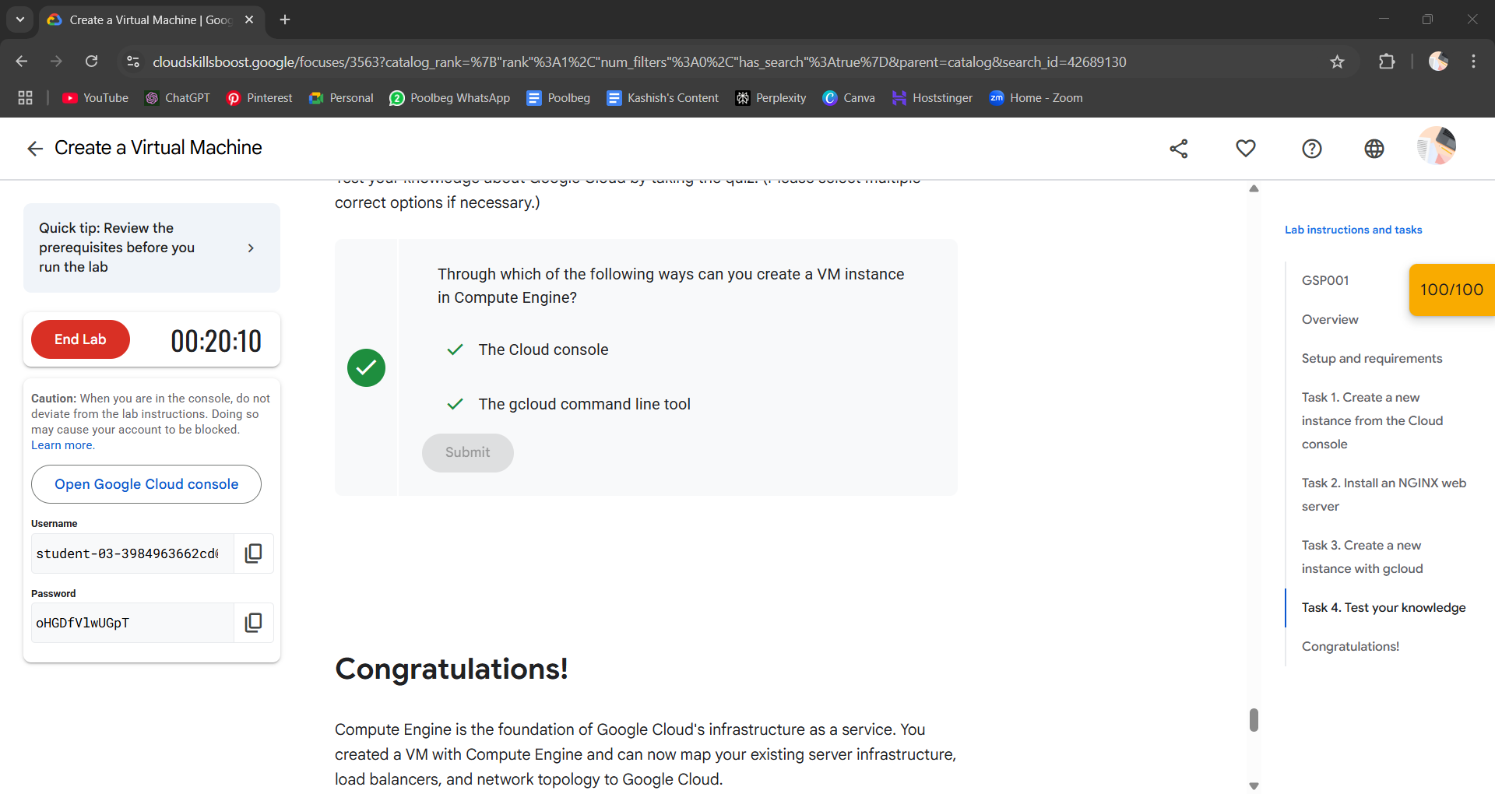

Conclusion:-
We created a Virtual Machine on GCP using Google Cloud Skills Boost.

